Testing

As programming of Clear Drive progresses, it will be subject to comprehensive testing at every stage of development from discovery, design, build, launch and development of later versions.

User testing, *Bring customers into every step of the dev process*, viewed on 16 August 2019, at <https://www.usertesting.com/platform/mobile-application-testing>

A marketing consultant will be engaged in the discovery phase to help understand our customers, their expectations and how to make them choose Clear Drive. This will identify our target users and their attitudes, likes, dislikes and frustrations they may have had using similar apps.

The findings from the discovery phase will feed into building specifications in the design phase. They will help guide decisions on the best features to include and prioritise development stages. Test users will be engaged through the marketing consultant to provide feedback and validation of Clear Drives design, to ensure it will provide a good user experience. Feedback collected at this stage will be integrated into the design of the prototype to ensure good user experiences.

After the prototype is built it will be extensively tested by Team Winterfell (and their friends, family) and other users from outside the team will be engaged by the consultant from a range of demographics, to test the app. This testing will be to assess the ease of navigation and use, to identify any bugs, performance issues or user experience issues and test Clear Drive on as many devices as possible (including the oldest to newest models). Users will be videoed using the app in real-life situations and feedback on any usability issues or dislikes will be gathered, analysed.

Clear Drive will also be tested to ensure it is fully accessible and compliant with legislative requirements within operating jurisdictions. Necessary adjustments will be made to fix any issues identified, which may include tweaking, adding or removing any features.

The research carried out in the early stages of development will be used to help develop a marketing campaign to attract potential customers in the launch phase.

Feedback and questions to Service and Support will be monitored to ensure that any issues identified when it used more broadly, are quickly addressed. Competitors and trends will also be monitored to identify features that would improve the app and these, where possible, will be included in later iterations to ensure Clear Drive remains the app of choice in a competitive in a market.

Timeframes

In order to develop the best mobile app we have invested significant time into mapping out each step of the development of our Clear Drive app in order to identify crucial milestones and interdependencies.

The detailed project Gant Chart maps out our planning and processes, from establishing our team, initial idea and research, planning, identification of specifications, app design, build, testing and deployment, while simultaneously developing a marketing strategy, engaging investors and a deployment partner.



Risks

**Distracted Driver Risks**

To increase the likelihood of success, we have actively identified and engaged with risk to reduce the possibility and consequence of adverse effects and to optimise the available opportunities. During our research phase into the threats to distracted drivers we adopted the bow tie model to identify and assess the threats, preventative controls, the hazard and the consequences if left uncontrolled.

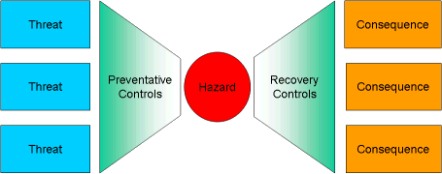

## Bowtie pro, *How does BowTie Pro Simplify Risk Management?*, viewed on 10 August 2019 at <https://customers.bowtiepro.com/KnowledgeBase/simpleRM/>

The image below illustrates the threats for distracted drivers, the hazard and the consequences.

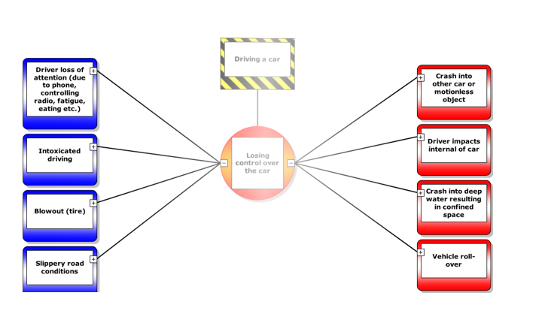

CGE Academy,*Threats png* viewed on 10 August 2019 at <https://www.cgerisk.com/knowledgebase/images/d/d7/Threats.png>

CGE Academy, *Consequences png* viewed on 10 August 2019 at <https://www.cgerisk.com/knowledgebase/images/d/d2/Consequences.png>

The focus of our app is to introduce a preventative control to remove one of the major driver distractions, mobile phones.

**Drive Clear App Development Risks**

To address the risks and protect the financial standing, reputation of Team Winterfell and the interests of investors, we recognise that risk management is everyone’s business, and integral to sound management and good governance of this development.

The ability to effectively engage with risk requires a combination of factors, including a positive risk culture, fit for purpose software, appropriately skilled people, and learning and development opportunities to build skills.

By first identifying the threats, hazards and consequences we have then put in place preventative controls to mitigate the risk strategies to recover controls to further address risks if needed

We have identified six main risks to the success of our project and the preventative and recovery controls to mitigate or remove the risks.

|  |  |  |  |  |
| --- | --- | --- | --- | --- |
| Threat | Preventative controls | Hazard | Recovery controls | Consequence |
| Users will not use or do not want app | * Carry out comprehensive market and user research before development * Design user friendly app * Carry out user testing | App is unsuccessful | * Gather feedback * Modify specifications to suit their requirements * Redesign app | App will fail to be adopted and monetised. |
| App not unique enough to be adopted | * Comprehensive research of apps already on the market * Identify most desirable functions * Identify market niche | Users will not use or do not want app | * Further user testing and market research * Add features * Redesign app | App will not stand out in the crowded marketplace and fail to be adopted and monetised. |
| Developing for many platforms | * Research which is the best platform for the app * Match platform to staff with skills and budget * Develop for one platform at a time | App not ready to deploy to all platforms | Identify second most suitable platform and  develop for it and other platforms | * Cost blowouts * App build incomplete * Not deployed to any platform |
| Choosing the wrong platform to build and deploy your app | * Carry out comprehensive research into platforms * Ensure long term viability of platform * Engage early with platform provider to ensure they will adopt Clear drive. | App rejected by platform provider | Modify specifications to suit their requirements | * App will fail to be adopted and monetised. |
| Risk of unsustainable user growth | * Include extension options in agreements or contracts * Include automated self-service ie help menus | App service and support unscalable | * Automate service * Build capability of current staff or employ more staff | * Must renegotiate hosting * Service and support unscalable |
| Staff vacancies/or absences | * Succession planning * Incentive bonuses * Training * Health and wellbeing programs | Unable to complete app development | * Upskill current staff * Recruit new staff | * Loss of invested capital * Loss of investors * Potential breach of contract * Loss of reputation |

Lifewire, Priya Viswanathan,*Native Apps vs. Web Apps: What Is the Better Choice?*

Viewed on 7 August 2019 at <https://www.lifewire.com/native-apps-vs-web-apps-2373133>

Entrepreneur, Himanshu Sareen, *5 Development Mistakes That Can Destroy Your Mobile App,* Viewed on 7 August 2019 at <https://www.entrepreneur.com/article/238849>

## Mrc, Joe Stangarone, *7 hidden risks of native mobile app development*, viewed on 7 August 2019, <https://www.mrc-productivity.com/blog/2013/11/7-hiddens-risks-of-native-mobile-app-development/>

## Group processes and communications

Due to the geographically dispersed nature of our team, communication was initially the most challenging aspect of this project. Strategies were employed to reach and engage as many team members as possible including the use of Discord, email and posting to our groups discussion page to assign tasks.

Introducing email meant that document sharing could be better facilitated, and team members were all kept up to date with the latest versions. The four active members of our team agreed to log in to Discord at regular assigned times throughout the week, so that we could discuss the project.

Building the tasks into a Gant Chart in the project plan provided oversight task progress and ensured that none were overlooked, and all had an assigned owner. We aimed to finish the project ahead of time so that we were aware of any tasks that had not been completed, leaving us time to follow up with the assigned team member and complete the tasks if needed.